**REACT CLASSES**

**DAY-(13 &14)**

**T SREE SOWMYA**

**CSE-04 IV YEAR**

**221910304044**

**Day-13 27/12/2022**

**Pure and Unpure component.**

A **Pure function** component the render is called only once.

Whenever u want to update or change anything the render () is not called.

***“Class App extends React.Purecomponent{}”***

**Unpure Component:** ***“Class App extends React.component{}”***

***Though after updation whenever u start updating by clicking on button ,those many time the render () is called***

In unpure component 🡪 you should keep (react.component)

1. **Pure Component:**

App.js

import React from 'react';

class Comp1 extends React.PureComponent {

render() {

   console.log('Child Component is called - Pure Component');

   return <h1>{this.props.value}</h1>;

}

}

class App extends React.Component {

state = { color: 'black' };

render() {

   return (

   <div style={{ color: this.state.color }}>

      <Comp1 value="Sowmya -4044" />

      <button onClick={() => this.setState({ color: 'green' })}>

      Change Color

      </button>

   </div>

   );

}

}

export default App;

**Output:**

Initially, colour is black.

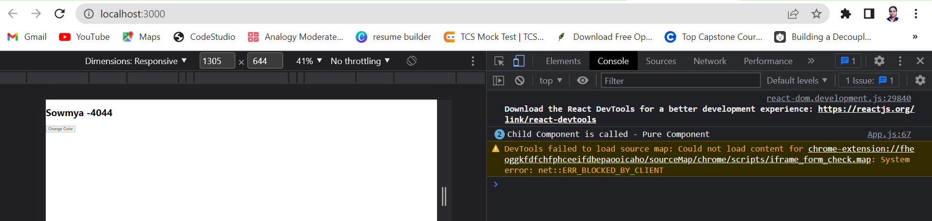

After changing colour to green🡪 render () is not called

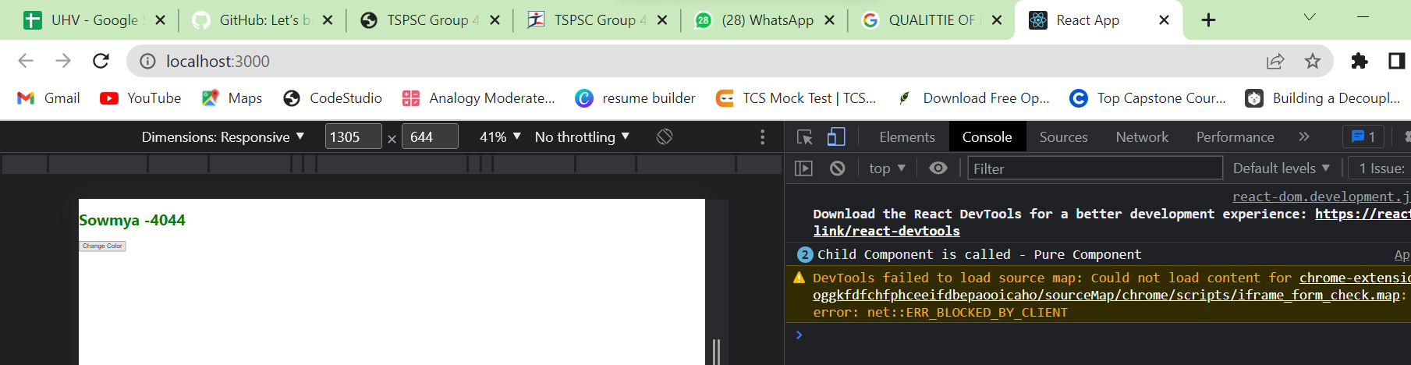

**Example -2:**

**Code:**

import './App.css';

import {useState} from 'react';

// import Gitamhyd from './Gitamhyd';

// import Student from './Student';

import User from './User'

// import React,{Component} from 'react';

// import GitamSowmya from './GitamSowmya';

import React,{PureComponent} from 'react'

class App extends PureComponent{

   constructor()

   {

      super();

      this.state={

         count:1

      }

   }

   render()

   {

      console.warn("check-rerending")

      return(

         <div className="App">

            <h1>Pure Component in React {this.state.count}</h1>

            <button

               onClick={()=>this.setState({count:this.state.count+1})}>

            Update Count</button>

         </div>

      )

   }

}

export default App;

**Output:**

**In console we can see the render**

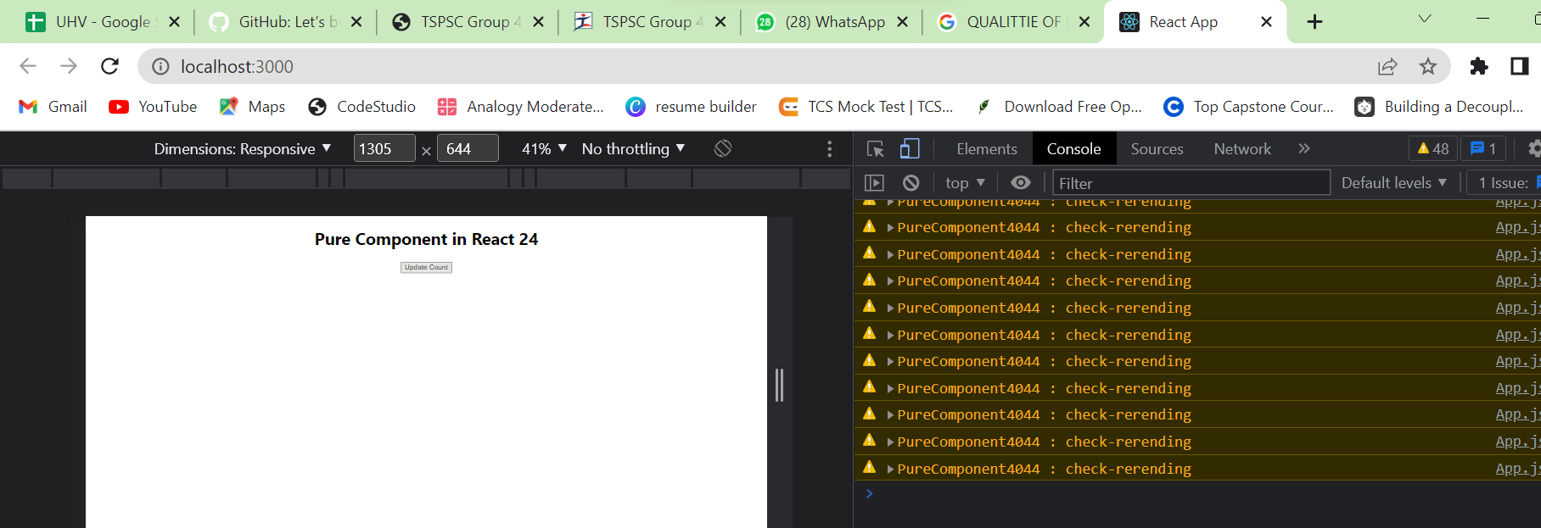

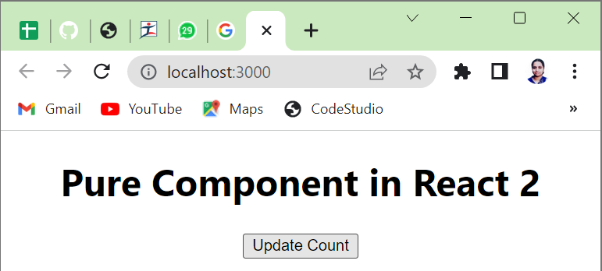

**Impure Component:**

**Code:**

**app.js**

import React from 'react';

class Comp1 extends React.Component {

render() {

   console.log('Child Component is called-Impure Component');

   return <h1>{this.props.value}</h1>;

}

}

class App extends React.Component {

state = { color: 'black' };

render() {

   return (

   <div style={{ color: this.state.color }}>

      <Comp1 value="Sowmya -4044" />

      <button onClick={() => this.setState({ color: 'green' })}>

      Change Color

      </button>

   </div>

   );

}

}

export default App;

**output:**

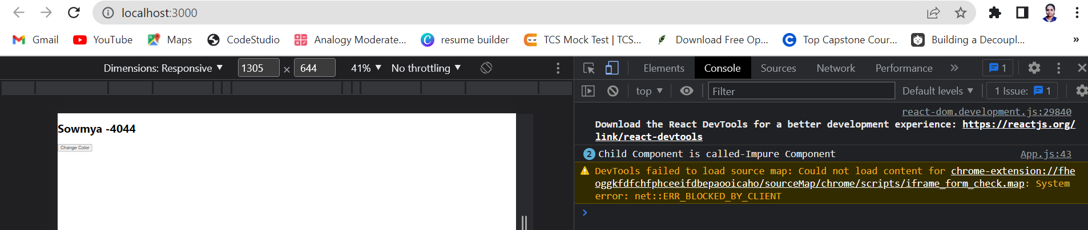

After clicking many times on button: the render() is called in console( and we can see child component thing calling many times)

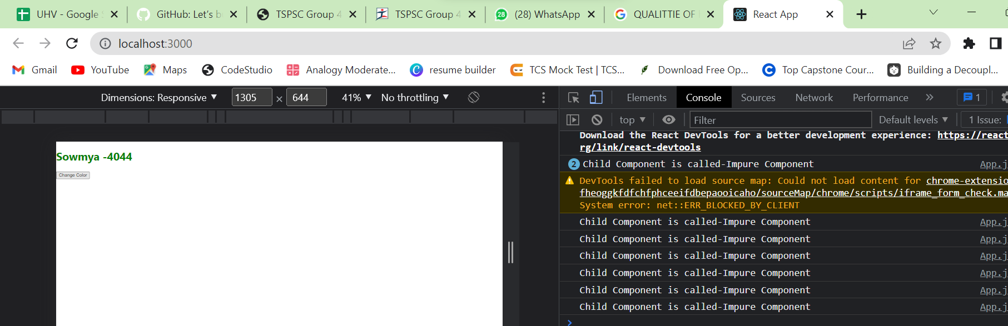

Create a class component ,in the class component create a state variable called “counter” and give initial value as “5”. Create Button “Your name” ..whenever u click on button the counter value to be added by 5 everytime. With pure component and normal component.

**Day-14** 28/12/2022

**high order component**

import './App.css';

import {useState} from 'react';

// import Gitamhyd from './Gitamhyd';

// import Student from './Student';

//import User from './User'

// import React,{Component} from 'react';

// import GitamSowmya from './GitamSowmya';

function App()

{

    return (

    <div className="App">

    <h1> HOC</h1>

    <HOC cmp={Counter} />

    </div>

    );

    }

function HOC(props)

{

    return <h2 style={{background:'red'}}><props.cmp></props.cmp></h2>

}

function Counter()

{

    const[count,setCount]=useState(0)

    return<div>

        <h3>{count}</h3>

        <button onClick={()=>setCount(count+1)}>Update</button>

    </div>

}

    export default App;

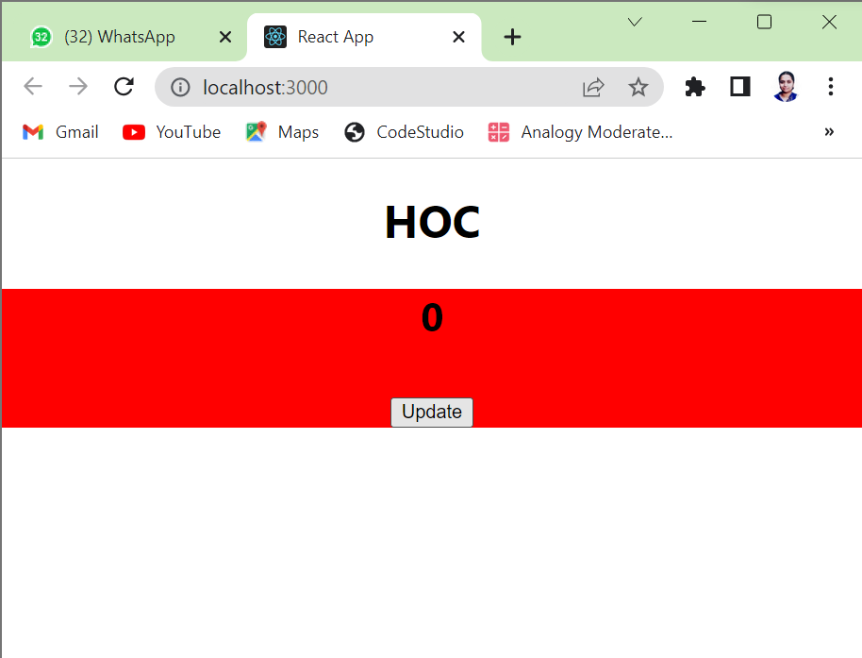

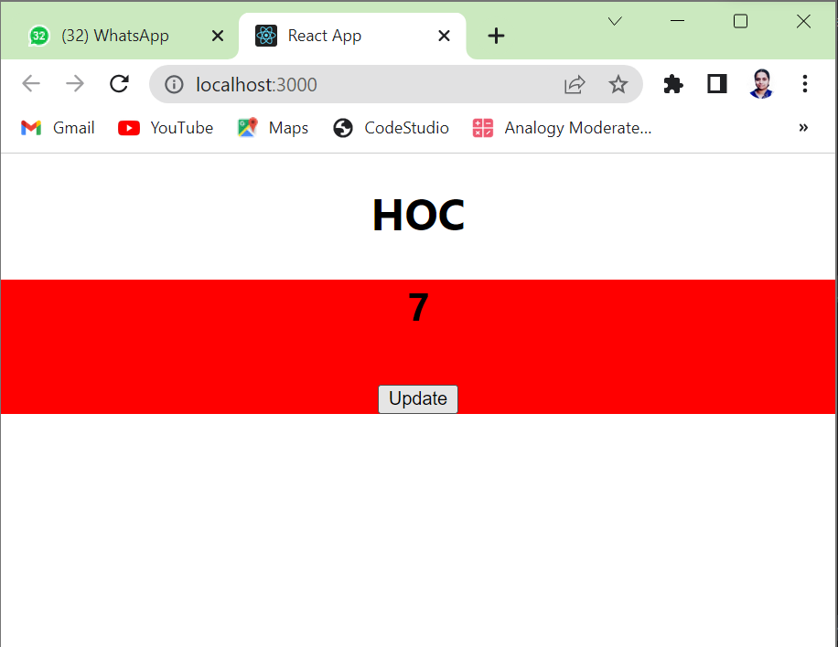

Transfering data from child to parent component.